ZX14 Tiger Tail Inner Fender Installation Instructions

- Remove Seat and rear cowling plastic
- Remove Fuel Tank (remove fuel too. Tank will be heavy otherwise)
- Remove tool kit and tool kit plastic tray.
- Disconnect all electrical harness mounted to your stock inner fender and key latch for seat.
- Remove stock bolts connecting plastic inner fender to sub-frame. (see reconnect pictures for locations)
- Transfer all rubber grommets and rubber collapse nuts to new Tiger Tail Inner Fender as shown.
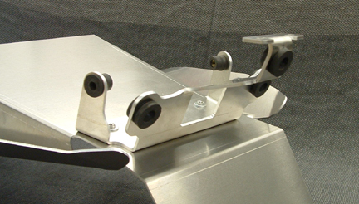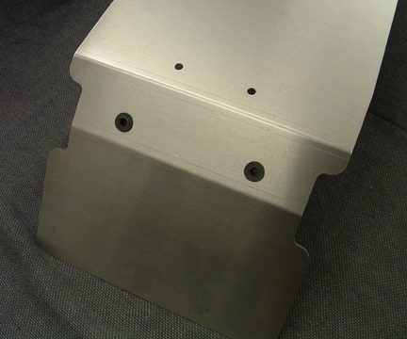

- Cut square metal brace off of key latch as shown and mount key latch using supplied spacers. Position back into sub-frame and connect rear of Inner Fender FIRST. See picture. You MUST put aluminum mount plate ON TOP of black hole tabs. NOT underneath. You can loosen the 2 bolts securing the brace to position the aluminum mount plate to help, and then retighten when positioned.
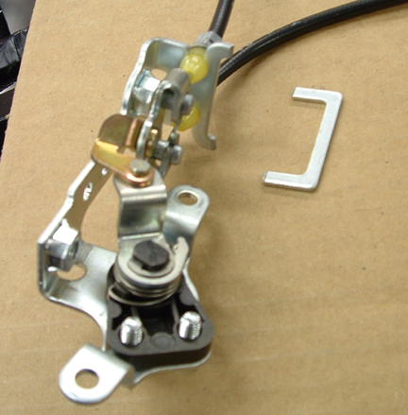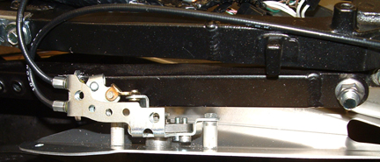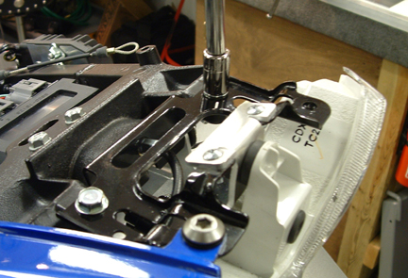

- Now install the two mount bolts that secure the inner fender to the sub-frame along the cross brace.
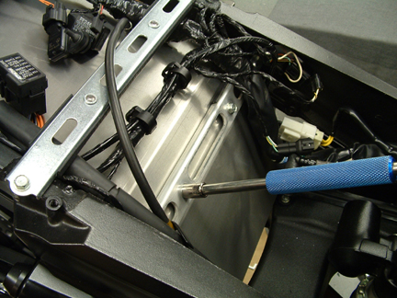

- Replace your electrical harness and check all connectors. You’re done. Re-install Fuel Tank and all plastic cowling covers.


